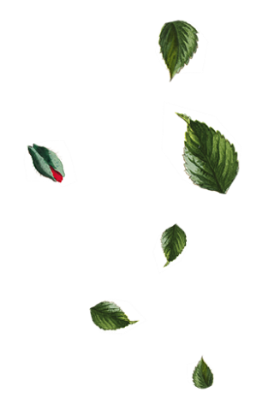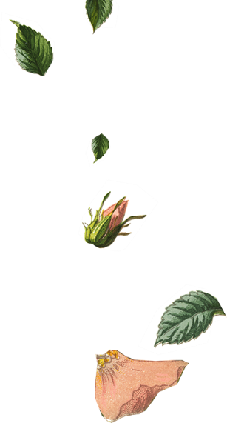

|  |  |  |  |  |
| --- | --- | --- | --- | --- |
|  | You are invited to join |  |  |  |
| Flora Persson  Kalle Astrom |  |  |  |
| & | |  |
|  |  |  |
| on our wedding day | |  |  |
|  | You are invited to join |  |  |  |
| Flora Persson  Kalle Astrom |  |  |  |
| & | |  |
|  |  |  |
| on our wedding day | |  |  |

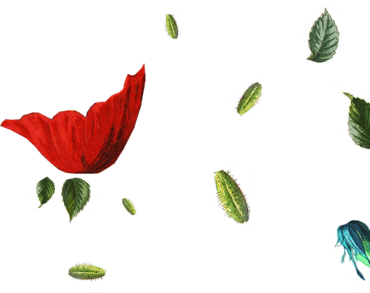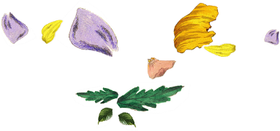

|  |  |
| --- | --- |
|  | Mr. & Mrs. Partner’s Parents  Request the honor of Your Presence  At the marriage of Partner’s Name To Partner’s Name Child of  Mr. & Mrs. Partner’s Parents Saturday the Twenty-First of JuneTwo thousand and [Year]Eleven O’clock in the morningAt Location City, State.Reception to Follow |
|  | Mr. & Mrs. Partner’s Parents  Request the honor of Your Presence  At the marriage of Partner’s Name To Partner’s Name Child of  Mr. & Mrs. Partner’s Parents Saturday the Twenty-First of JuneTwo thousand and [Year]Eleven O’clock in the morningAt Location City, State.Reception to Follow |